Smart Seating Allocation System for Examination Management

Introduction
The Seating Arrangement System for examination/test in college/university is a GUI-based desktop application developed to automate the process of allocating examination rooms to the students of various classes/departments based on the student strength and available room capacity. The system supports two allocation modes: Semester and Class Test, and allows selection of student data year-wise or class-wise. The application will be installed in a standalone system for execution and getting results.
The application includes a secure login system with a predefined user id and password, restricted to authorised COE office/Examination Cell personnel only, along with a password recovery option for authorised users. Upon successful authentication, the user can upload the required data files and configure the allocation parameters. The system then generates an optimised room allotment by distributing classes/departments among the different rooms, aiming to minimise room usage and maximise space utilisation. When a room has remaining capacity after accommodating one department, another department is assigned to fill the leftover seats, with the room capacity updated to reflect the remaining available seats.
Final room assignments are generated in an MS-Excel file and also displayed in a structured table for verification and instant view.
This application streamlines manual seating planning and ensures fair and efficient distribution of resources during examination periods.
Technologies Chosen
Frontend:
Data Processing:
- Pandas
- OpenPyXL
Data Input:
- Microsoft Excel (.xlsx / .xls)
Development Tools:
- Node.js / npm
- Git

- React.js
- HTML/CSS (inline styles)
- JavaScript (ES6+)
Backend:
- Python
- Flask
- Flask-CORS
System Configuration
Hardware Requirements:
- Processor — Intel Core i5 / AMD Ryzen 5 5600G with Radeon Graphics (3.90 GHz)
- RAM — Minimum 4 GB
- Storage — Minimum 500 MB free disk space
- Display — 1024 x 768 resolution or higher
Software Requirements:
- Operating System — Windows 10/11
- Python 3.8 or above
- Node.js 14 or above
- Any modern web browser (Google Chrome, Microsoft Edge, Mozilla Firefox)
Network Requirements:
- No internet connection required (runs on localhost)
- Local network access optional (for multi-device access)
Input File Requirements:
- Department Data file in .xlsx / .xls format
- Room Data file in .xlsx / .xls format
Installation & Setup
No installation is required. The application is provided as a standalone executable file (app.exe).
To run the application:
- Locate the app.exe file provided to you
- Double-click app.exe
- A browser window will open automatically at http://localhost:5000
- The application is now ready to use
Note: Do not close the black command window that may appear in the background, it is the server running the application. Closing it will stop the app.
How to Use
Step 1 — Authentication
- Enter the authorised username and password (Username: COE-office,
Password: AB@2026C)
- Click Authenticate
- If credentials are incorrect, 3 attempts are allowed before access is locked
- If you have forgotten your password, click Forgot Password? and answer the security question to reset it

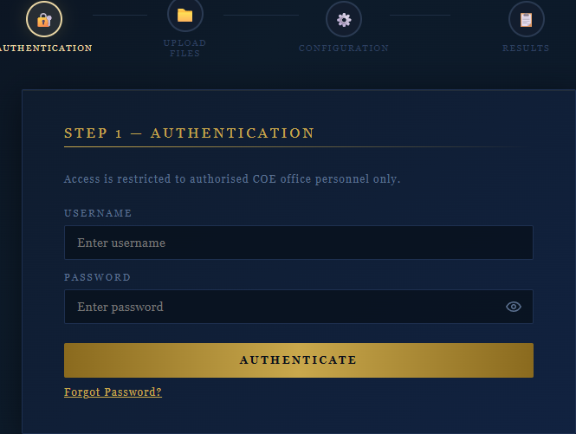
Step 2 — Upload Data Files
- Upload the Department Data Excel file (.xlsx).
- Upload the Room Data Excel file (.xlsx).
- Click Preview & Select.
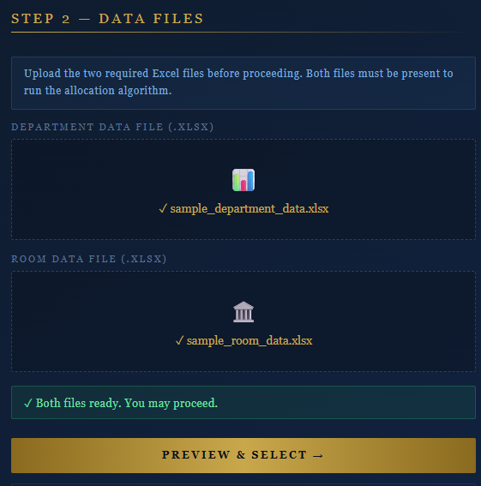
Step 3 – Select Rooms and Departments
- Select the rooms to include in the allocation.
- Select the departments for each academic year.
- Review the selection summary.
- Click Confirm & Proceed to Configuration.
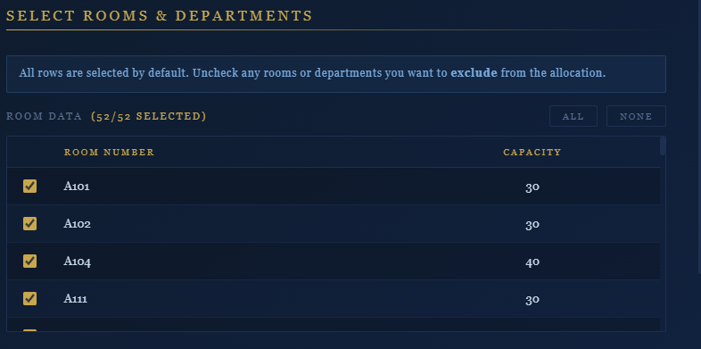
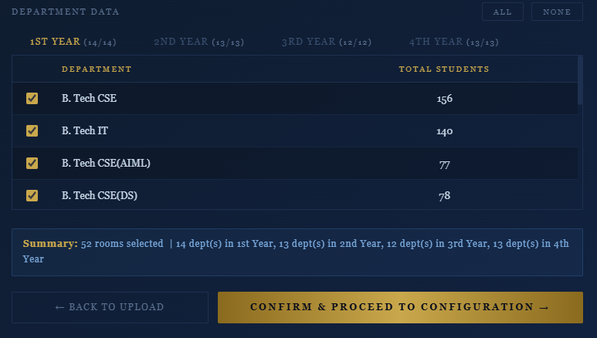
Step 4 — Allocation Configuration
- Select the Examination Mode — Semester or Class Test
- For Semester — select the academic year from the dropdown
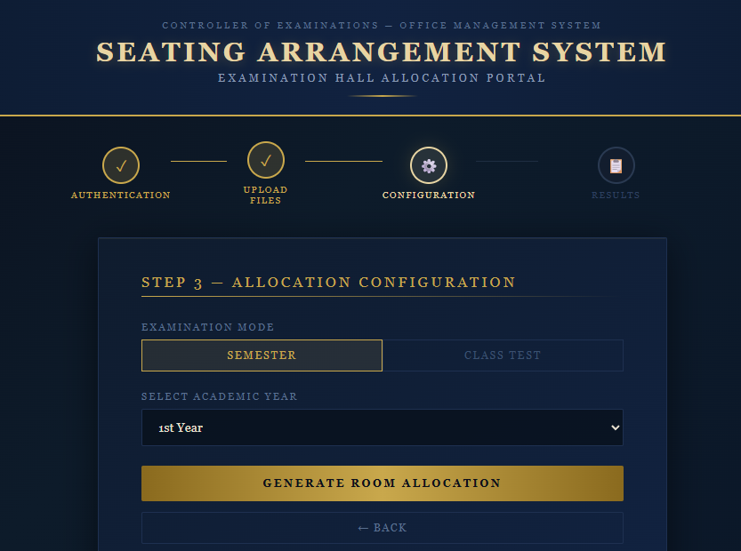
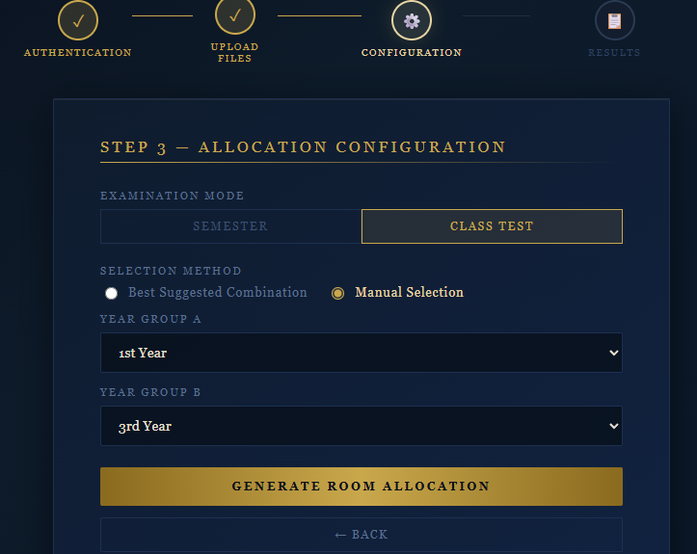
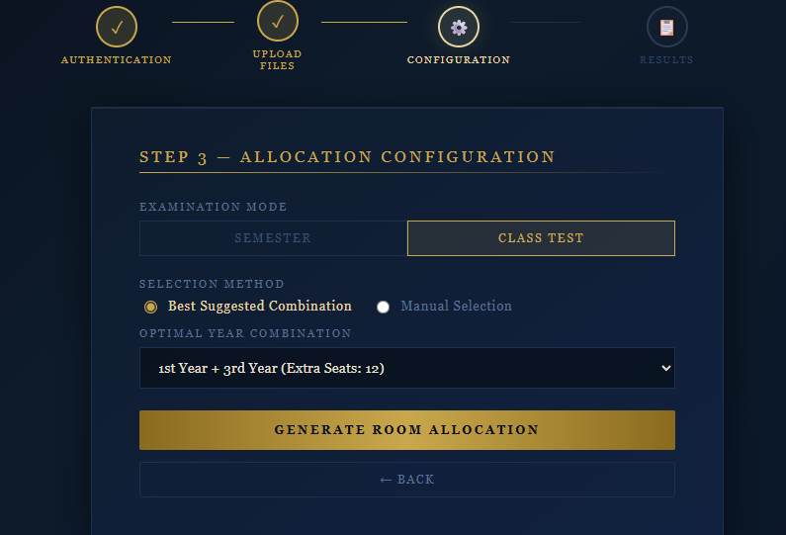
- For Class Test — choose either the system-suggested best year combination or manually select two-year groups
- Click Generate Room Allocation
Step 5 — View Results
- The allocation results are displayed in a structured table
- Columns shown: Department, Room Allocated, Allocated Strength, Room Capacity
- For Class Test mode, results are shown in two tabs — one for each year group

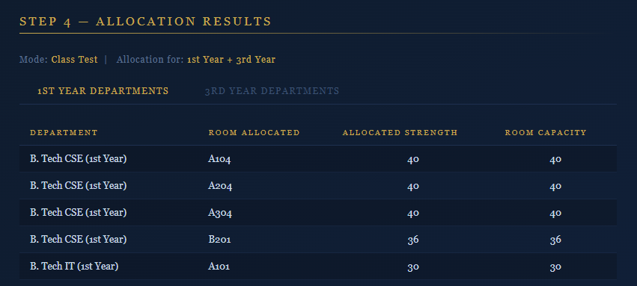
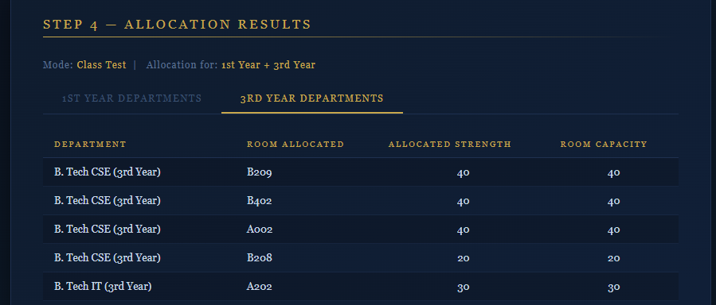
Step 6 — Export Results
- Click Export to Excel to download the allocation as an Excel file
- The file will be saved to your default Downloads folder
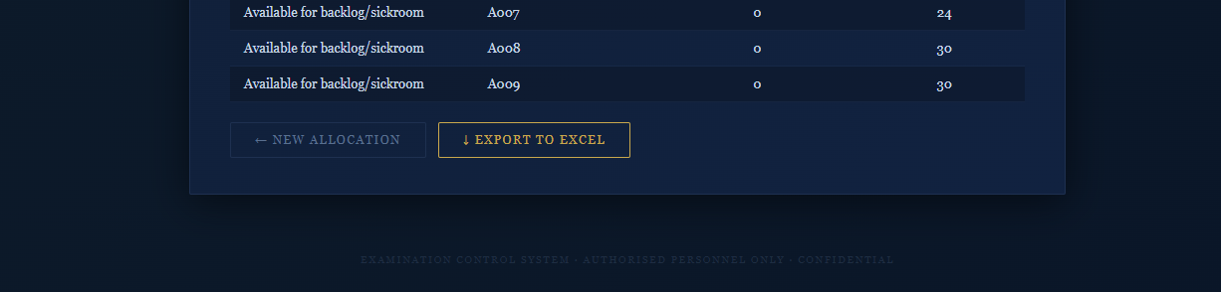
Input File Format
The application requires two Excel files (.xlsx format):
Room Data File:
- Must contain exactly two columns:
  - Room_Number — the room identifier (e.g. A101, B202)
  - Capacity — the maximum seating capacity of the room (numeric)
Department Data File:
- Must contain separate sheets named exactly:
  - 1st Year
  - 2nd Year
  - 3rd Year
  - 4th Year
- Each sheet must contain exactly two columns:
  - Department — the department name (e.g. B. Tech CSE)
  - Total_Students — the number of students (numeric)
Important: Column names and sheet names must match exactly as shown above. Any spelling difference will cause an error.

